---------------------------------------------------------------------

-- LAB 05

--

-- Exercise 1

---------------------------------------------------------------------

USE TSQL;

GO

---------------------------------------------------------------------

-- Task 1

--

1-- Write a SELECT statement that will return the custid, companyname, contactname, address, city, country, and phone columns from the Sales.Customers table.

2-- Filter the results to include only the customers from the country Brazil.

--

3-- Execute the written statement and compare the results that you got with the desired results shown in the file 52 - Lab Exercise Task 1 Result.txt.

---------------------------------------------------------------------

---------------------------------------------------------------------

-- Detyre 1

--

1-- Selektoni kolonat custid, companyname, contactname, address, city, country, dhe phone nga tabela

Sales.Customers.

2-- Filtro rezultatin per te perfshire vetem klientet nga shteti i Brazilit.

--

3-- Ekzekuto veprimet dhe krahaso rezultatet qe moret me rezultatet e rekomanduara ne dokumentin 52 –

Lab Exercise Task 1 Result.txt.

---------------------------------------------------------------------

1--

Select sc.custid CustomerId,sc.companyname CompanyName , sc.contactname ContactName,sc.address Address,sc.city City , sc.country Country,sc.phone Phone

From Sales.Customers sc

2--

Select * From Sales.Customers sc Where sc.country='Brazil'

3—Ekzekutimi i dy querive të mësipërme në pikat 1&2:

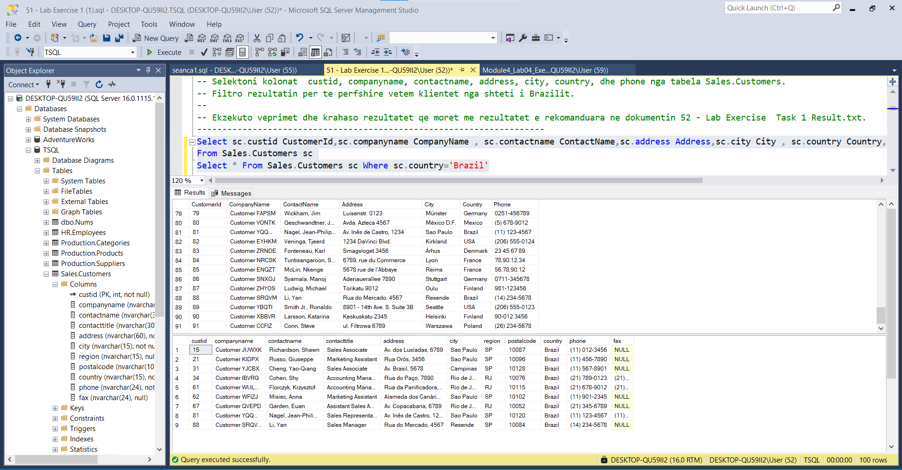

QUERY1.txt

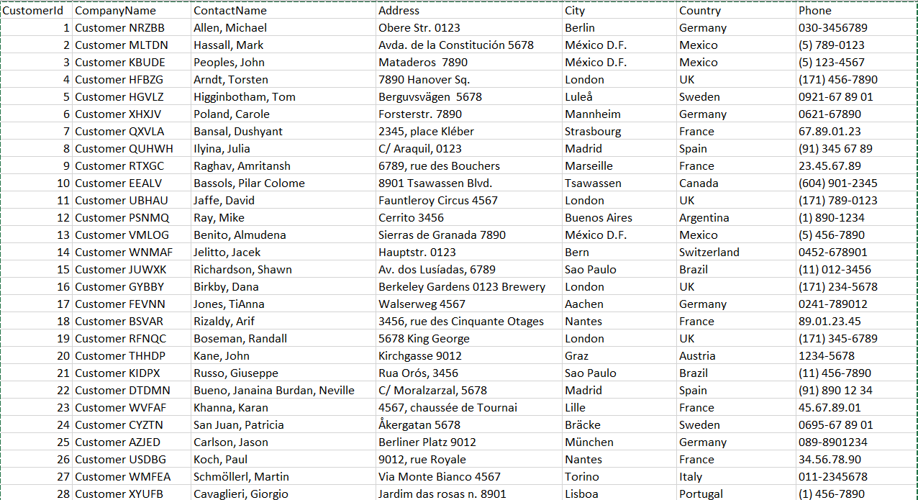

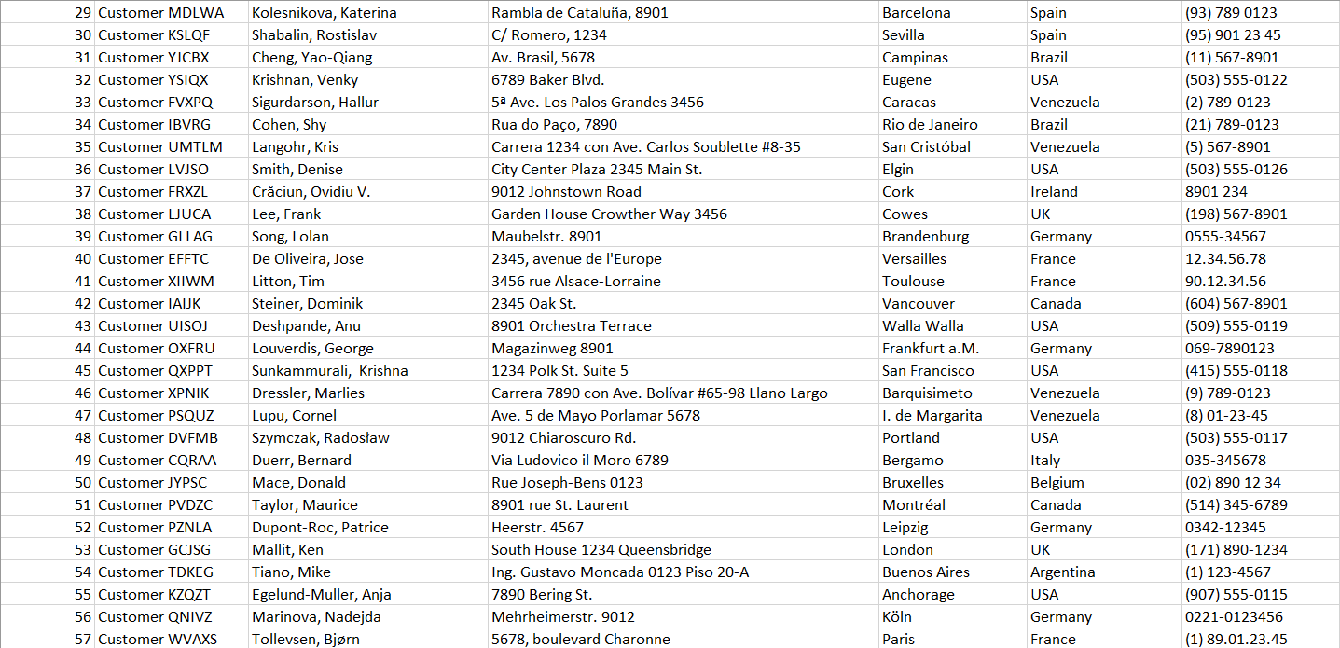

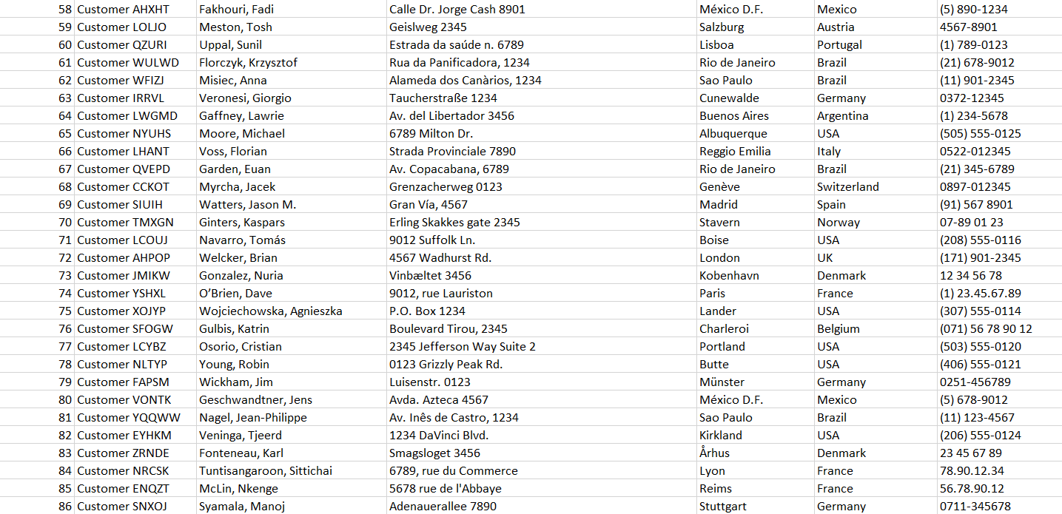

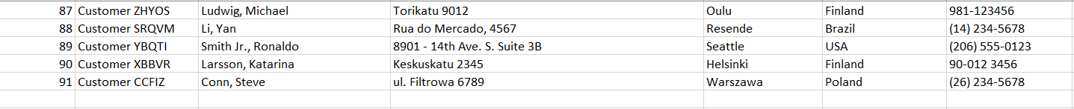

Query2.txt



---------------------------------------------------------------------

-- Task 2

--

-- Write a SELECT statement that will return the custid, companyname, contactname, address, city, country, and phone columns from the Sales.Customers table.

-- Filter the results to include only customers from the countries Brazil, UK, and USA.

--

-- Execute the written statement and compare the results that you got with the desired results shown in the file 53 - Lab Exercise 1 - Task 2 Result.txt.

---------------------------------------------------------------------

---------------------------------------------------------------------

-- Detyre 2

--

1-- Selektoni kolonat custid, companyname, contactname, address, city, country, dhe phone nga tabela

Sales.Customers.

2-- Filtro rezultatin per te perfshire vetem klientet nga shtetet Brazil, UK, dhe USA.

--

3-- Ekzekuto veprimet dhe krahaso rezultatet qe moret me rezultatet e rekomanduara ne dokumentin 53 –

Lab Exercise 1 - Task 2 Result.txt.

---------------------------------------------------------------------

1--

Select sc.custid CustomerId,sc.companyname CompanyName , sc.contactname ContactName,sc.address Address,sc.city City , sc.country Country,sc.phone Phone

From Sales.Customers sc

Where sc.country IN (‘Brazil’,’UK’,’USA’)

2--

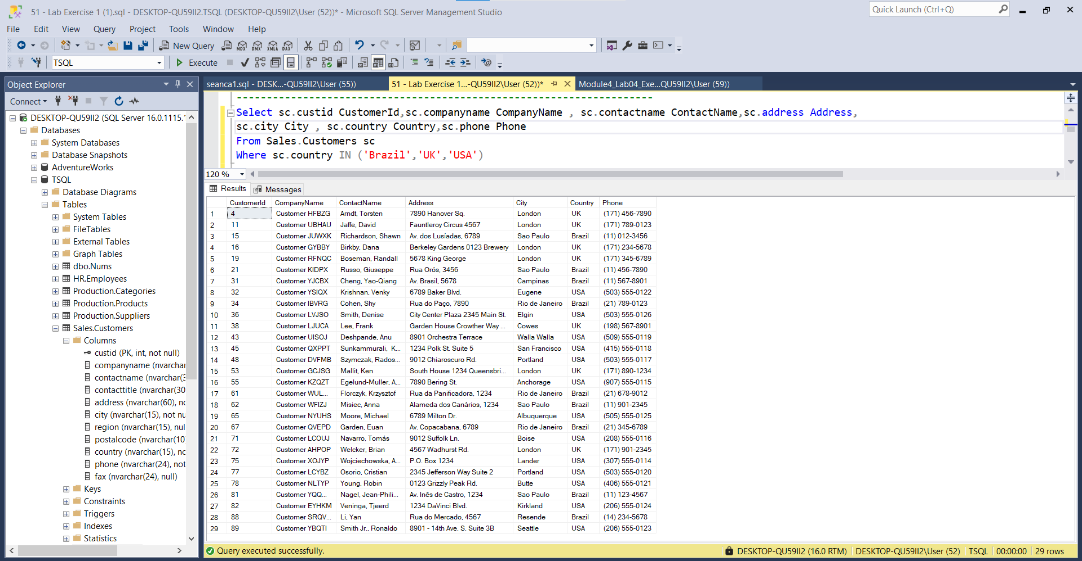

Result.txt

|  |  |  |  |  |  |  |
| --- | --- | --- | --- | --- | --- | --- |
| CustomerId | CompanyName | ContactName | Address | City | Country | Phone |
| 4 | Customer HFBZG | Arndt, Torsten | 7890 Hanover Sq. | London | UK | (171) 456-7890 |
| 11 | Customer UBHAU | Jaffe, David | Fauntleroy Circus 4567 | London | UK | (171) 789-0123 |
| 15 | Customer JUWXK | Richardson, Shawn | Av. dos Lusíadas, 6789 | Sao Paulo | Brazil | (11) 012-3456 |
| 16 | Customer GYBBY | Birkby, Dana | Berkeley Gardens 0123 Brewery | London | UK | (171) 234-5678 |
| 19 | Customer RFNQC | Boseman, Randall | 5678 King George | London | UK | (171) 345-6789 |
| 21 | Customer KIDPX | Russo, Giuseppe | Rua Orós, 3456 | Sao Paulo | Brazil | (11) 456-7890 |
| 31 | Customer YJCBX | Cheng, Yao-Qiang | Av. Brasil, 5678 | Campinas | Brazil | (11) 567-8901 |
| 32 | Customer YSIQX | Krishnan, Venky | 6789 Baker Blvd. | Eugene | USA | (503) 555-0122 |
| 34 | Customer IBVRG | Cohen, Shy | Rua do Paço, 7890 | Rio de Janeiro | Brazil | (21) 789-0123 |
| 36 | Customer LVJSO | Smith, Denise | City Center Plaza 2345 Main St. | Elgin | USA | (503) 555-0126 |
| 38 | Customer LJUCA | Lee, Frank | Garden House Crowther Way 3456 | Cowes | UK | (198) 567-8901 |
| 43 | Customer UISOJ | Deshpande, Anu | 8901 Orchestra Terrace | Walla Walla | USA | (509) 555-0119 |
| 45 | Customer QXPPT | Sunkammurali, Krishna | 1234 Polk St. Suite 5 | San Francisco | USA | (415) 555-0118 |
| 48 | Customer DVFMB | Szymczak, Radosław | 9012 Chiaroscuro Rd. | Portland | USA | (503) 555-0117 |
| 53 | Customer GCJSG | Mallit, Ken | South House 1234 Queensbridge | London | UK | (171) 890-1234 |
| 55 | Customer KZQZT | Egelund-Muller, Anja | 7890 Bering St. | Anchorage | USA | (907) 555-0115 |
| 61 | Customer WULWD | Florczyk, Krzysztof | Rua da Panificadora, 1234 | Rio de Janeiro | Brazil | (21) 678-9012 |
| 62 | Customer WFIZJ | Misiec, Anna | Alameda dos Canàrios, 1234 | Sao Paulo | Brazil | (11) 901-2345 |
| 65 | Customer NYUHS | Moore, Michael | 6789 Milton Dr. | Albuquerque | USA | (505) 555-0125 |
| 67 | Customer QVEPD | Garden, Euan | Av. Copacabana, 6789 | Rio de Janeiro | Brazil | (21) 345-6789 |
| 71 | Customer LCOUJ | Navarro, Tomás | 9012 Suffolk Ln. | Boise | USA | (208) 555-0116 |
| 72 | Customer AHPOP | Welcker, Brian | 4567 Wadhurst Rd. | London | UK | (171) 901-2345 |
| 75 | Customer XOJYP | Wojciechowska, Agnieszka | P.O. Box 1234 | Lander | USA | (307) 555-0114 |
| 77 | Customer LCYBZ | Osorio, Cristian | 2345 Jefferson Way Suite 2 | Portland | USA | (503) 555-0120 |
| 78 | Customer NLTYP | Young, Robin | 0123 Grizzly Peak Rd. | Butte | USA | (406) 555-0121 |
| 81 | Customer YQQWW | Nagel, Jean-Philippe | Av. Inês de Castro, 1234 | Sao Paulo | Brazil | (11) 123-4567 |
| 82 | Customer EYHKM | Veninga, Tjeerd | 1234 DaVinci Blvd. | Kirkland | USA | (206) 555-0124 |
| 88 | Customer SRQVM | Li, Yan | Rua do Mercado, 4567 | Resende | Brazil | (14) 234-5678 |
| 89 | Customer YBQTI | Smith Jr., Ronaldo | 8901 - 14th Ave. S. Suite 3B | Seattle | USA | (206) 555-0123 |

**Rezultatet jane te njejta

---------------------------------------------------------------------

-- Task 3

--

1-- Write a SELECT statement that will return the custid, companyname, contactname, address, city, country, and phone columns from the Sales.Customers table.

2-- Filter the results to include only the customers with a contact name starting with the letter A.

--

3-- Execute the written statement and compare the results that you got with the desired results shown in the file 54 - Lab Exercise 1 - Task 3 Result.txt.

---------------------------------------------------------------------

---------------------------------------------------------------------

-- Detyre 3

--

1-- Selektoni kolonat custid, companyname, contactname, address, city, country, dhe phone nga tabela

Sales.Customers.

2-- Filtro rezultatin per te perfshire vetem emrat e kontakteve qe fillojne me shkronjen "A".

--

3-- Ekzekuto veprimet dhe krahaso rezultatet qe moret me rezultatet e rekomanduara ne dokumentin 54 –

Lab Exercise 1 - Task 3 Result.txt.

---------------------------------------------------------------------

1&2--

Select sc.custid CustomerId,sc.companyname CompanyName , sc.contactname ContactName,sc.address Address,sc.city City , sc.country Country,sc.phone Phone

From Sales.Customers sc

Where ContactName Like ‘A%’

3--

Result.txt

|  |  |  |  |  |  |  |
| --- | --- | --- | --- | --- | --- | --- |
| CustomerId | CompanyName | ContactName | Address | City | Country | Phone |
| 1 | Customer NRZBB | Allen, Michael | Obere Str. 0123 | Berlin | Germany | 030-3456789 |
| 4 | Customer HFBZG | Arndt, Torsten | 7890 Hanover Sq. | London | UK | (171) 456-7890 |

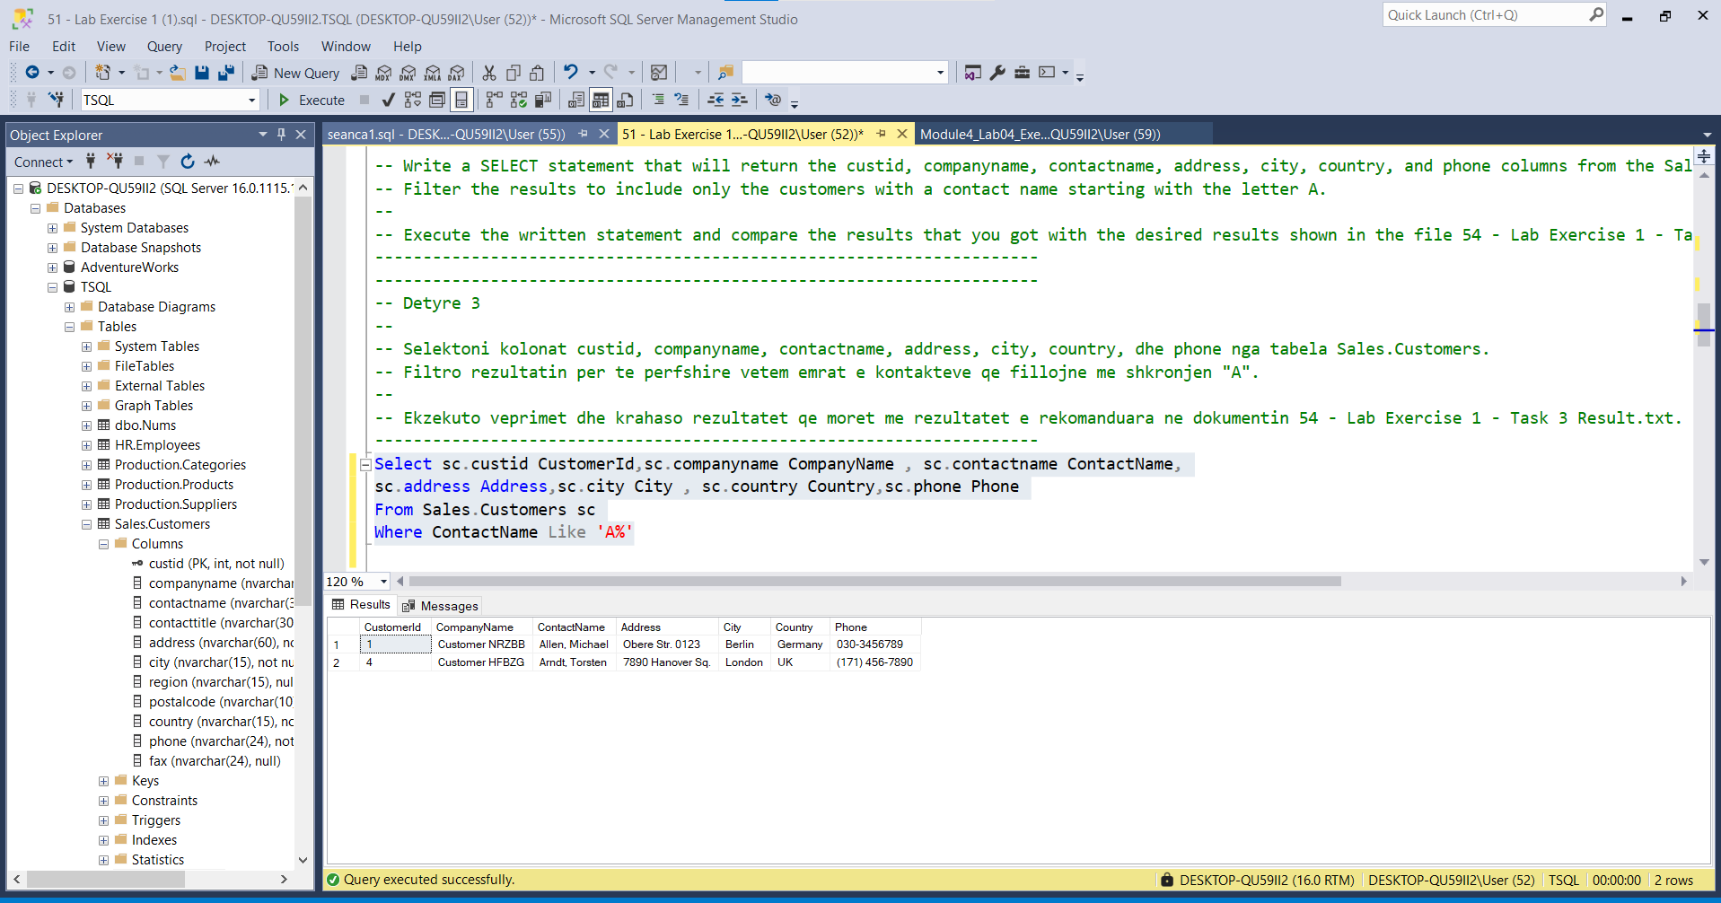

---------------------------------------------------------------------

-- Task 4a

--

-- The IT department has written a T-SQL statement that retrieves the custid and companyname columns from the Sales.Customers table and the orderid column from the Sales.Orders table.

--

-- Execute the query. Notice two things:

-- First, the query retrieves all the rows from the Sales.Customers table.

-- Second, there is a comparison operator in the ON clause specifying that the city column should be equal to the value “Paris”.

---------------------------------------------------------------------

SELECT

c.custid, c.companyname, o.orderid

FROM Sales.Customers AS c

LEFT OUTER JOIN Sales.Orders AS o ON c.custid = o.custid AND c.city = N'Paris';

---------------------------------------------------------------------

-- Task 4b

--

-- Copy the provided T-SQL statement and modify it to have a comparison operator for the city column in the WHERE clause. Execute the query.

--

-- Compare the results that you got with the desired results shown in the file 55 - Lab Exercise 1 - Task 4 Result.txt.

--

-- Is the result the same as in the first T-SQL statement? Why? What is the difference between specifying the predicate in the ON clause and in the WHERE clause?

---------------------------------------------------------------------

---------------------------------------------------------------------

-- Detyra 4a

--

1-- Departamenti i IT ka shkruar nje kod T-SQL qe nxjerr kolonat custid dhe companyname nga tabela

Sales.Customers dhe kolonen orderid nga tabela Sales.Orders.

--

2-- Ekzekuto query. Vë re dy gjera:

-- Se pari, query nxjerr te gjitha rrjeshtat nga tabela Sales.Customers.

-- Se dyti, eshte nje operator krahasimi ne klazulen On duke specifikuar qe kolona city duhet te jene

e barabarte me vleren "Paris".

---------------------------------------------------------------------

1&2&3--

SELECT

c.custid, c.companyname, o.orderid

FROM Sales.Customers AS c

LEFT OUTER JOIN Sales.Orders AS o ON c.custid = o.custid AND c.city = N'Paris';

Ekzekutimi:

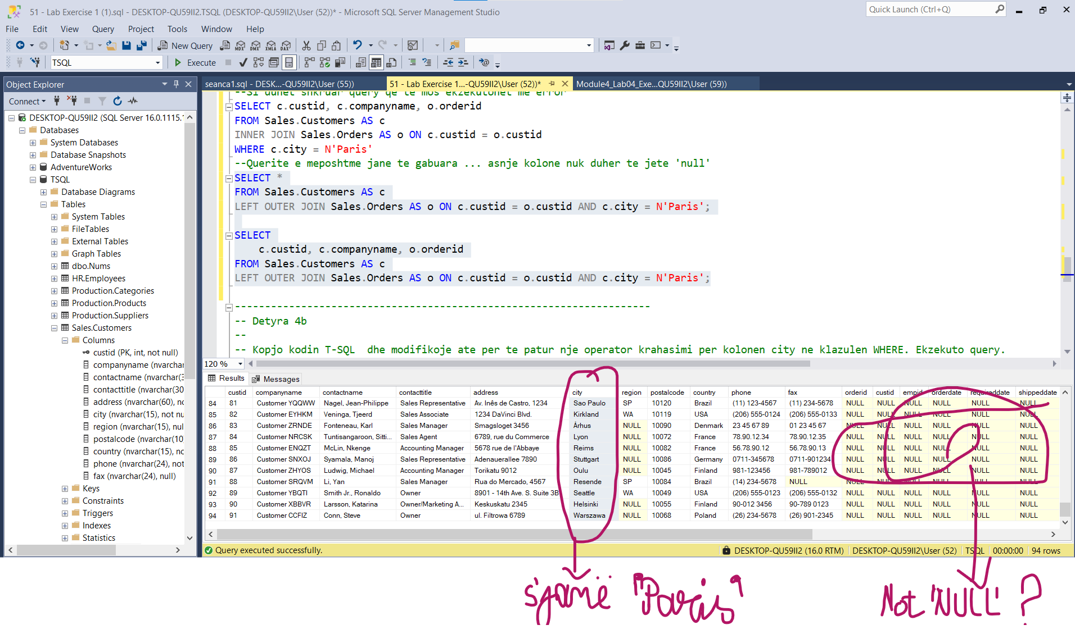

Rezultati I querise qe gjeneron rezultatin e sakte:

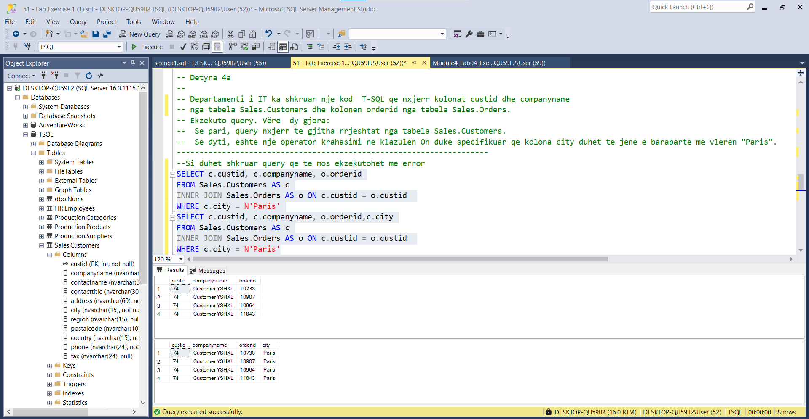

**I njejti rezultat

---------------------------------------------------------------------

-- Detyra 4b

--

1-- Kopjo kodin T-SQL dhe modifikoje ate per te patur nje operator krahasimi per kolonen city ne

klazulen WHERE. Ekzekuto query.

--

2-- Krahaso rezultatet qe moret me rezultatet e rekomanduara ne dokumentin 55 - Lab Exercise 1 - Task

4 Result.txt.

--

3-- A eshte rezultati i njejte si ne kodin e pare te T-SQL? Pse? Cila eshte diferenca midis

specifikimit te predicate ne klazulen ON dhe specifikimit ne klazulen WHERE?

---------------------------------------------------------------------

***Eshte specifikuar ne 4b

---------------------------------------------------------------------

-- Task 5

--

1-- Write a T-SQL statement to retrieve customers from the Sales.Customers table that do not have

matching orders in the Sales.Orders table.

2-- Matching customers with orders is based on a comparison between the customer’s custid value and

the order’s custid value.

3-- Retrieve the custid and companyname columns from the Sales.Customers table.

-- (Hint: Use a T-SQL statement that is similar to the one in the previous task.)

--

4-- Execute the written statement and compare the results that you got with the desired results shown in the file 56 - Lab Exercise 1 - Task 5 Result.txt.

---------------------------------------------------------------------

---------------------------------------------------------------------

-- Detyra 5

--

1-- Shkruani nje T-SQL per te nxjerre klientet nga tabela the Sales.Customers qe nuk kane perputhje

porosish nga tabela Sales.Orders.

2-- Kombinimi i klienteve me porosite eshte i bazuar ne krahasimin midis the vleres se customer’s

custid dhe vleres se order’s custid.

3-- Nxjerr kolonat custid dhe companyname nga tabela Sales.Customers.

-- (Udhezim: Perdor nje T-SQL qe eshte e ngjashme me ate te detyres me para.)

--

4-- Ekzekuto veprimet dhe krahaso rezultatet qe moret me rezultatet e rekomanduara ne dokumentin 56 - Lab Exercise 1 - Task 5 Result.txt.

---------------------------------------------------------------------

1—

Select * From Sales.Customers c LEFT OUTER JOIN Sales.Orders o ON c.custid=o.custid

Where o.orderid IS NULL

2--

Ekzekutimi i querise:

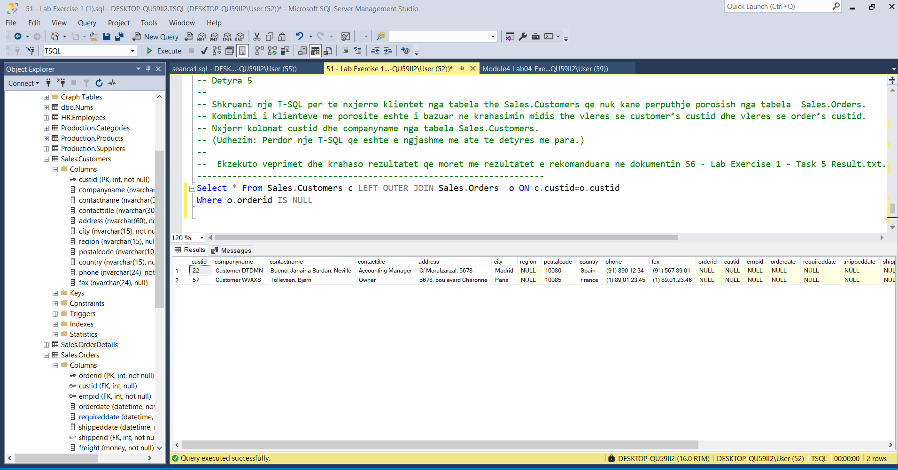

3--

Select c.companyname CompanyName,c.custid CustomerId From Sales.Customers c LEFT OUTER JOIN Sales.Orders o ON c.custid=o.custid

Where o.orderid IS NULL

Ekzekutimi: 